**CONTENTS**

**CHAPTER NO TITLE PAGE NO.**

**ACKNOWLEDGEMENT I**

**ABSTRACT II**

**LIST OF TABLE AND FIGURE 2**

**1 INTRODUCTION 3-4**

**2 APPLICATION OF PNEUMATICS 5-7**

**3 DESCRIPTION OF EQUIPMENT 8-10**

**4 DESIGN OF EQUIPMENT AND DRAWING 11-12**

**5 FABRICATION 13-14**

**6 MECHANISM DESIGN 15-17**

**7 MAINTENANCE AND OPERATIONS GUIDANCE 18**

**8 ADVANTAGES AND APPLICATION 19**

**9 LIST OF MATERIALS 20-21**

**10 COST ESTIMATION 22-23**

**11 CONCLUSION**

**12 REFERENCE**

**CHAPTER-1**

**INTRODUCTION**

**FUNDAMENTALS OF PNEUMATICS**

**Fluid power**

Fluid power is the use of a fluid (liquid or gas) to transmit power from one location to another.

**Pneumatics**

Pneumatics deals with the study of the behavior and application of compressed air.

**Pascal’s law**

The pressure exerted on a confined fluid is transmitted undiminished in all directions and acts at right angles to the containing surfaces.

**Gas laws**

To understand pneumatic system, we must first understand the behavior of gases.Their behavior is described by the perfect gas laws describe the relationships among pressure temperature and volume for most gases under a wide range of conditions. Air follows these laws very closely under the condition that are found in pneumatic systems.

**Boyle’s law**

Which state that the absolute pressure of a confined gas is inversely proportional to its volume temperature remains constant.

**Pα1/V**

**PV=CONSTANT**

**P1V1=P2V2**

Where P1=absolute pressure of the gas at state 1

V1=volume of the gas at state 1

P2=absolute pressure of the gas at state 2

V2=volume of the gas at state 2

**Charles’s law**

Its state that the volume of a confined gas is proportional to its temperature,

**V α T**

**V/T=CONSTANT**

**V1/T1=V2/T2**

Where V1=volume f the gas at state 1

T1=absolute temperature of the gas at state 1

V2=volume of the gas at state 2

T2=absolute temperature of the gas at state 2

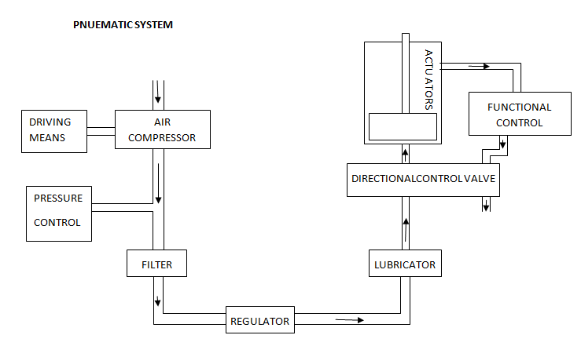

**CHAPTER-2**

**APPLICATION OF PNEUMATICS**

**CONSTRUCTION:** when it comes to moving dirt or rock for roads ,tunnels and dams etc. pneumatically controlled shovels, scrappers, diggers etc are invariably used.

**AGRICULTURE:** Paddy transplaters , harvesting machines controlled whether for animals breeding pneumatic controlled conveyor mechanisms.

**MINING:** Control of material handling systems in mixers drilling equipment, remote control of equipment in explosive weather and in case of underground mining where electrical equipment is hazardous.

**PAPER INDUSTRY:** In production of paper the pulp must pass through many stages of continuous web flow .Throughout the paper mills pneumatic power devices may be found such as feeders dryers , vibrators ,hydro pulpers and finishing tables.

**CHEMICAL INDUSTRY:** Pneumatically operated devices are remote control valves feeding materials to mixers weighing machines controls hot air oven etc.

**PLASTICS:** Plastic fabrication is a molding business. Injection, perform, laminated and vacuum moldings pressures are all exerted and controlled by fluid power system.

**RUBBER:** Fluid power may be seen in many places in rubber industry in the production of new synthetics and in fabrication of finishing products.

**MARINE:** One of the classic jobs of fluid power in marine shipping is automatic helmsman ship cargo handling is a partially fluid power job. Much of the dock and shipyard machinery is either hydraulic or pneumatics.

**METAL WORKING AND MACHINE TOOLS :** Controlling the table movements of a milling machine , feeding and cutting tools on an automatic lathe advancing and feeding twist drills , actuating the ram of a branch or clamping the work in chuck there are all routine jobs for fluid power .

**STEEL:** To convert steel ingot into a fine gleaming sheet or into a reel of wire enormous pressure is required. Roll pressure is maintained by fluid power.

**PNEUMATIC COMPONENTS**

AIR COMPRESSORS

A machine that increases the pressure of air by increasing its density and delivering the fluid against the connected system resistance on the discharge side. The compressor is basically an air pump that compresses air into receiver tank. The receiver tank acts as pressure source from which the system can draw as by the flow demand.

TYPES OF AIR COMPRESSORS

There are two basic types of compressors

1. Positive displacement
2. Dynamic (turbo) compressor

POSITIVE DISPLACEMENT: Positive displacement compressors work on the principle of increasing the pressure of a definite volume of air by reducing that volume in an enclosed chamber . positive displacement compressor are subdivided into 2 groups.

1. Reciprocating type compressor.
2. Rotary type compressor.

DYNAMIC (TURBO) COMPRESSOR: This type of rotating vanes or impellers to impart velocity and pressure to flow of air being handled . pressure comes from the dynamic effects such as centrifugal force.

**WORKING:**

With the starting of the prime mover the crank rotates and piston in the cylinder sucks atmospheric air through the suction filter and inlet valve on further rotation of the crank the piston reverser and it compressed the air, the compressed air forces the outlet valve open and escapes through outlet valve and is fed to the receiver tanks.

They are classified as follows

1. Single acting compressor
2. Double acting compressor
3. Single stage compressor
4. Multistage compressor

**OBJECTIVE OF PROJECT**

The main objective of our project is to perform “climbing operation” by using “tree climbing robot” in which pneumatic equipments performs a major role .By using this equipment human efforts will be reduced. Time and energy will be saved to a possible state or rate . By using this equipment the accidents that happen during harvesting will be minimized. And moreover harvesting will be much easier than conventional method.

**NEED FOR PNEUMATICS**

Pneumatics forms an attractive medium for low cost. The main advantage of a pneumatic system is that it is economical and simple in construction which makes it different from other sources of system. Maximum power can be transmitted and controlled by operating simple levers. Much simple than complicated circuits.

Pneumatic system plays an important role in mass production. Now-a-days almost almost all the manufacturing process is changing to pneumatics. In order to deliver the products with better quality and ay a faster rate. The manufacturing operation is being pneumatics for the following reasons.

* To achieve mass production
* To reduce man power
* To increase the efficiency of the plant.
* To reduce the production cost
* To reduce the production time
* To reduce the fatigue of the worker
* To achieve good product quality
* Less maintenance

**CHAPTER-3**

**DESCRIPTION OF EQUIPMENT**

**5/2 LEVER OPERATING DIRECTION CONTROL VALVE:**

In certain designs of DC valves, 5 openings are preferred instead of 4 openings. This ensures easy exhausting of the valve. Figure shows a 5/2 lever type DC valve. Here the spool slides inside the bore as given below:

**Position-1:** when the spool is actuated towards outer direction, port ‘P’ connects to ‘B’ and remains closed while ‘A’ gets connected to ‘R’.

**Position-2:** when the spool is actuated towards inner direction, port ’P’ and ‘A’ get connected to each other and ‘B’ to ‘S’ while port ‘R’ remains closed.

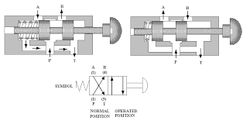

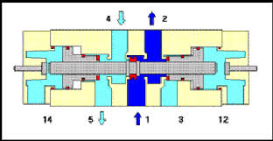

**FRL UNIT ( FILTER,REGULATOR AND LUBRICATOR ):**

The air from the compressor is clean and purified by the filter. The system performance and accuracy depends much on the pressure-stability of the air supply. An air line filter and a pressure regulator along with the lubricator , finds a very important place in the pneumatic system. The main function is to provide the air with a lubricating film of oil. These three units together are called service unit or FRL unit.

The main three element of an FRL unit are:

**1.Air filter**

**2.Pressure regulator**

**3.Lubricator**

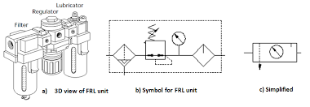

**CONNECTORS:**

In our system we used the hose connector. Hose connectors normally comprise an adoptee hose nipple and cap nut. These types of connectors are made up of brass (or) aluminum (or) hardened pneumatic steel.

**PU TUBES AND FITTINGS:**

Polyurethane flexible tubing is available in sizes from 1/16” to 1” inside diameter. This pure polyurethane tubing is recommended for use with high-purity applications, instrumentation and handling of pneumatic based products.

**PNEUMATIC DOUBLE ACTING CYLINDER:**

A double acting cylinder is employed in control system with the full pneumatic cushioning and it is essential when the cylinder itself is required to retard heavy loads. This can only be Done at the end positions of the piston stock. In all intermediate positions a separate externally mounted cushioning device must be provided with the damping feature.

The normal escape of air is out off by a cushioning piston before the end of the stock is required. As a result the sit in the cushioning chamber is again compressed since it cannot escape but slowly according to the setting made on reverses.

The air freely enters the cylinder and piston stokes in the other direction at full force and velocity.

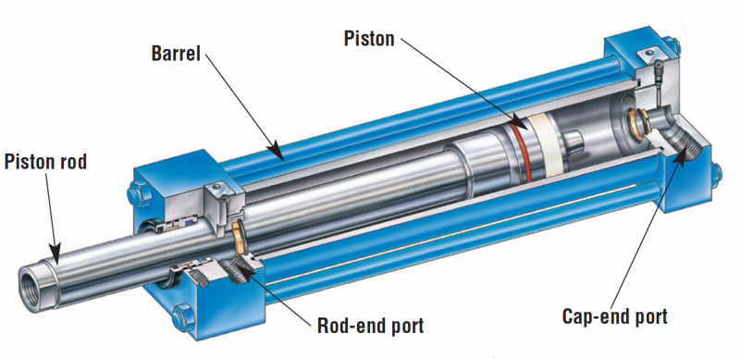

**CHAPTER-4**

**DESIGN OF EQUIPMENT AND DRAWING**

**PNEUMATIC COMPONENT AND SPECIFICATION**

The pneumatic tree climbing unit consists of the following components

1. Double acting pneumatic cylinder
2. 5/2 lever operated DC valve
3. Flow control valve
4. Connectors
5. Hoses

**1.Double acting pneumatic cylinder Technical data**

**Main cylinder:**

Stroke length : 300 mm

Piston diameter : 50 mm

Quantity : 01

**Auxiliary cylinder: Technical data**

Stroke length : 50 mm

Piston diameter : 25 mm

Quantity : 02

Media : Air

Temperature **:** 5-60c

Pressure range : 0.5-10 bar

**2. 5/2 lever operated DC valve Technical data**

Port size :

Temperature : 0-100

Media : air

Quantity : 2

**3 Connector Technical data**

Pressure range : 10bar

Temperature : 0-100c

Material : stainless steel

Media : air

Quantity : 10

**4 Hoses Technical data**

Pressure range : 10bar

Temperature : 0-100c

Media : air

Inner diameter : 8mm

Outer diameter : 10mm

**CHAPTER-5**

**FABRICATION**

**METHOD OF FABRICATION:**

The arms are vertically fixed on the cylinder by means of bolt and nuts. The top arm is fixed with the help of the block and the block is fixed at the end of the piston rod of the main actuator.

The upper and lower arms are fixed to the auxiliary actuators by means of bolts and nuts. The actuators are fixed with the help of aluminum clamps.

These arms support the equipment and it also helps in climbing the tree. The clamping unit is fixed to support the springs of the arms.

Finally the unit is connected to the compressor by means of hoses.

**CHAPTER-6**

**MECHANISM DESIGN**

The robot consists of three pneumatic actuators. The main actuator has a 30cm effective stroke and can deliver 500 Newton force at 5 bar (it could carry a 50kg payload). The two other actuators are smaller with a stroke of 5cm and their task is to open and close the upper arm and lower leg. Special aluminum seats were designed to hold the small actuators in a horizontal position on the arm and leg. Each small actuator is attached with two seats one for the base another for the bases of stainless steel flat blocks have been manufactured to connect the main actuator with the arms. The upper base is cubic with one hole on the datum to join with the main actuator and another on the side connecting with the arm. The lower end of the main actuator is attached directly to the base of the actuator with four screws. It has a part to connect lower arm to it. The arms were manufactured from aluminum to keep minimum weigh

It connects together to embrace the trunk To control the system manually at first, two 3/2 way push button control valves were used. One is responsible for raising the upper arm and opening it while keeping the grip of the lower arm to the trunk of the tree. Providing compressed air to the other small actuator does the opposite; opening the lower arm while closing the upper arm to grip the trunk.

The air that operates the system comes from a 7 bar compressor. The assembly drawing of the robot mechanism and an exploded view of this robot are shown below Fig. 1.



Below is a list of components used in the climbing robot:

1. The Main Actuator:
2. The auxiliary actuator
3. Fork arm.
4. Circular tube.
5. Upper base.
6. Lower base.
7. The platform.
8. Cylindrical box (x2)
9. Extension Springs.
10. Auxiliary Actuator seat
11. U-shaped Bar
12. Rods Final Design

From the primary design to the “final” design there were many experiments and iterations that led to several modifications to the robot design and consequently arrived at the “final” design shown in Fig.



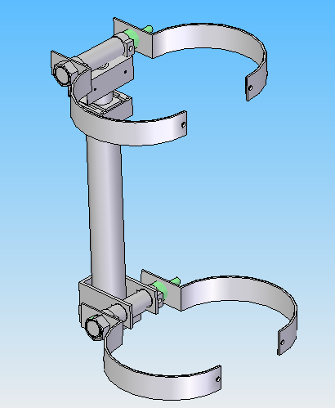

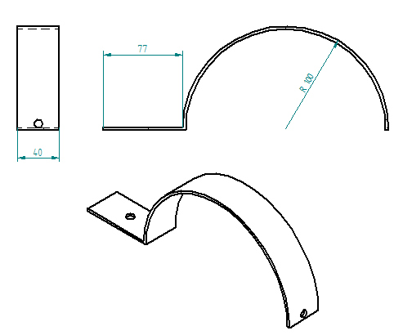

ARM

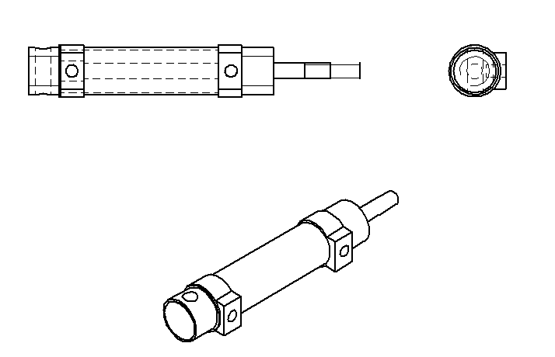

AUXILIARY ACTUATOR

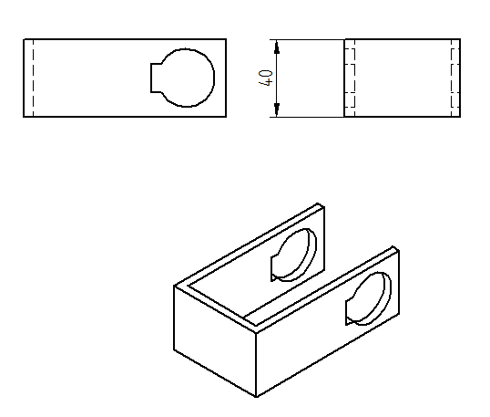

FORK ARM

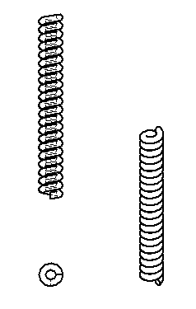

EXTENSION SPRINGS.

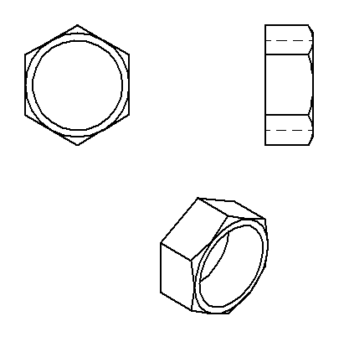

NUT-1

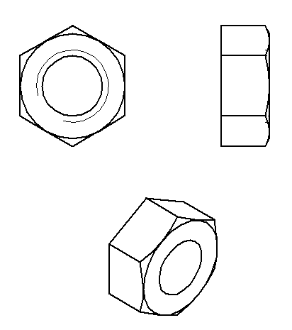

NUT-2

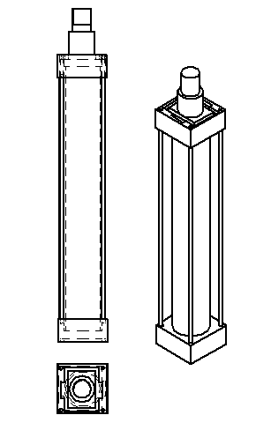

MAIN CYLINDER

**CHAPTER-7**

**MAINTENANCE AND OPERATION GUIDANCE**

**SAFETY CAUTIONS:**

* Always use clean and dry air to operate the tool and keep working area clean.
* Loose fittings and connections should be avoided.
* Do not use damaged, frayed or deteriorated air hoses and fitting.
* When the work is finished turn off the air source.

**TO USE:**

* Turn on the air source such as air compressor and allow air tank to be filled.
* Set the regulator of air source to 10 bar. This tool are operated at the maximum 10 bar pressure.

**SAFETY CAUTIONS:**

* Do not use damaged, frayed or deteriorated air hoses and fitting.
* Always use clean and dry air to operate the machine and keep working area clean.
* Do not lubricate tool with flammable or volatile liquids such as kerosene, diesel or fuel.
* Make sure that arms are fixed correctly or not.
* Operate the valves according to the sequence of motion .
* When the work is finished turn off the air source.

**CHAPTER-8**

**ADVANTAGES AND APPLICATIONS**

**ADVANTAGES:**

* It requires less time.
* No Labour cost.
* Good safety to the operator.
* Break down chances are less.
* Harvesting rate is high.

Semi Skilled labours are required

**APPLICATIONS**

* It is used in agriculture field.
* It is used for harvesting.
* It is used to spray the pesticides on the trees .

**CHAPTER-9**

**LIST OF MATERIALS**

**FACTORS DETERMINING THE CHOICE OF MATERIALS**

The various factors which determine choice of material discussed below are

**1. Properties:**

The materials selected must possess the necessary properties for the proposed application.The various requirements to be satisfied can be weight, surface finish, rigidity, ability to withstand environmental attack from chemicals, service life, reliability etc.

The following four types of principle properties of materials decisively affect their selection

1. Physical
2. Mechanical
3. From manufacturing point of view
4. Chemical

The various physical properties concerned are melting point, thermal conductivity, specific heat, co-efficient of thermal expansion, specific gravity, electrical conductivity, magnetic purposes etc.

The various mechanical properties concerned are strength in tensile, compressive shear, bending, torsion and buckling load, fatigue resistance, impact resistance, elastic limit, endurance limit, and modulus of elasticity, hardness, wears resistance and sliding properties.

**2. Manufacturing case:**

Sometimes the demand for lowest possible manufacturing cost or surface qualities obtainable by the application of suitable coating substances may demand the use of special materials.

**3. Quality Required:**

This generally affects the manufacturing process and ultimately the material. For example, it would never be desirable to go for casting of a less number of components which can be fabricated much more economically by welding or hand forging the steel.

**4. Availability of materials:**

Some materials may be scarce or in short supply. It then becomes obligatory for the designer to use some other material which though may not be a perfect substitute for the material designed. The delivery of materials and the delivery date of product should also be kept in mind.

**5.Space consideration:**

Sometimes high strength materials have to be selected because the forces involved are high and the space limitations are there.

**6.Cost:**

As in any other problem , in selection of material the cost of material plays an important part and should not be ignored. Sometimes factors like scrap utilization, appearance, and non maintenance of the designed part are involved the selection of proper materials.

Table 1.1 LIST OF MATERIAL

|  |  |  |  |
| --- | --- | --- | --- |
| SL NO | DESCRIPTION | QUANTITY | MATERIAL |
| 1 | Double acting pneumatic cylinder | 3 | Aluminum |
| 2 | 5/2 lever operated DCV | 3 | Mild steel |
| 3 | FRL unit | 1 | Steel |
| 4 | Manifold | 1 | Aluminum |
| 5 | PU tubes | 35 meter | Polyurethane |
| 6 | Connector | 22 | Steel |
| 7 | Push-Pull valve | 1 | Steel |
| 8 | Arms | 4 | Aluminum |
| 9 | Block | 1 | Aluminum |
| 10 | Clamp | 3 | Aluminum |
| 11 | Springs | 2 | Steel |

.

**CHAPTER-10**

**COST ESTIMATION**

**1. MATERIAL COST:**

TABLE 1.2 COST ESTIMATION

|  |  |  |  |  |
| --- | --- | --- | --- | --- |
| SL NO | DESCRIPTION | QUANTITY | MATERIAL | AMOUNT IN  Rs. |
| 1 | Double acting pneumatic cylinder | 3 | Aluminum | 5300 |
| 2 | 5/2 lever operated DCV | 3 | Mild steel | 2550 |
| 3 | FRL unit | 1 | Steel | 2230 |
| 4 | Manifold | 1 | Aluminum | 230 |
| 5 | PU tubes | 35 meter | Polyurethane | 1100 |
| 6 | Connector | 22 | Steel | 1260 |
| 7 | Push-Pull valve | 1 | Steel | 850 |
| 8 | Arms | 4 | Aluminum | 410 |
| 9 | Block | 1 | Aluminum | 150 |
| 10 | Clamp | 3 | Aluminum | 330 |
| 11 | Springs | 2 | Steel | 50 |
| 12 | Table | 1 | M . S | 1500 |
| Total material cost | | | | 15,960 |

**2. LABOUR COST:**

LATHE, DRILLING, WELDING, GRINDING, BENDING, Etc.:

Cost : Rs.2220/-

**3. PRIME COST:**

Prime cost is the addition of material cost and labour cost .

Prime cost = Material cost + Labour cost

= 15,960 +2220

= **Rs . 18,180/-**

**4.OVERHEAD CHARGES :**

The overhead charges are also called as indirect expenses or on -cost.

Overhead charges = Indirect expenses + Indirect material cost

= 670+510

**= Rs 1180 /-**

**TOTAL COST :**

Total cost = prime cost + Overhead charges

= 18180+1180

Total cost for this project = **Rs .19560/-**

**CHAPTER-11**

CONCLUSION

In this work a tree climbing mechanism for ARECA nut trees has been proposed this mechanism can also be used to climb structures and other trees which are almost straight like areca trees, poles etc. the mechanism used in this robot is a bio inspired mechanism which is derived from an organism.

FUTURE SCOPE:

In the future, the climber can be fully automated. Instead of manual controlling, the whole operation can be programmed into a micro controller. Pressure sensors can be used to determine how much pressure to be applied after the bush comes in contact with the tree. A robotic arm can be used to harvest areca nut.

REFERNCES

1. Journal of Automation and Control Engineering Vol.4
2. K.R. Asfar, “Pole climbing robot, Patent Application,2013
3. B. Yazdani, M. Ahmadabadi, A. Harati, H. Moaveni, and N. Soltani, “Design and development of a pole climbing robot mechanism
4. Internet –
   1. [www.wikipedia](http://WWW.Wikipedia).org
   2. www.howstufworks.com
   3. [www.youtube.com](http://www.youtube.com)
   4. [www.google](http://www.google).co.in